Hi students,

There are two books available on internet for free that I use in this course and I recommend you widely. I also shared with you previously:

1. Digital Systems Principles and Applications. Ronald J. Tocci. 10th Ed. [1]
2. Digital design With an Introduction to the Verilog HDL. F5th Ed. M. Morris Mano [2]
3. **Take a look at section"1-2 DIGITAL AND ANALOG SYSTEMS" by TOCCI and write some advantages using digital systems**

s

1. **Do the following base conversions**

|  |  |  |
| --- | --- | --- |
| **Dec** | **Bin** | **Hex** |
| 804 | 1100100100 | 324 |
| 2048 | 100000100100 | 824 |
| 3279 | 110011001111 | CCF |
| 13965 | 11011010001101 | 368D |
| 62453 | 1111001111110101 | F3F5 |
| 6890 | 1101011101010 | 1AEA |

**Answer the following questions using your own words.**

1. **What is a computer?**

It is an electronic machine capable of receiving, processing and returning results based on certain data and that to carry out this task has an input and an output means.

1. **What is a program?**

When we speak specifically of a computer program, we are referring to software. These are applications and resources that allow the development of different tasks on a computer (computer), a telephone or other technological equipment.

1. **Why we use digital computers instead analog computers? Give some advantages or disadvantages as you consider.**

* Digital computers:
  + Its operation is based on the count of the values that are introduced.
  + This type of computer must be programmed before being used for any specific purpose.
  + They are general purpose machines; given a program, they can solve virtually all kinds of problems.
  + They are precise, they provide exactly the correct answer to a specific problem.
  + These computers have a large internal memory, where millions of characters can be entered.
  + These computers are the most widely used.
  + Currently 95% of the computers used are digital due to its great utility at a commercial, scientific and educational level.
* Analog computers:
  + They work based on analogies.
  + They require a physical process, a pointer, and a scale.
  + Analog computers do not compute directly, but constantly perceive varying physical values, signals, or quantities.
  + They are fast but the direct nature of the circuits that compose them make them even faster.
  + Programming on these computers is not necessary; calculus relations are constructed and are part of these.
  + They are specific purpose machines.
  + They give approximate answers, since they are designed to represent electronically some sets of data from the real world, so their results are close to reality.
  + These are generally used to monitor real world conditions such as Wind, Temperature, Sound, Motion, etc.

1. **Which semiconductor device is the basis of a digital component?**

TTL (transistor-transistor logic) uses the bipolar transistor as its main circuit element, while CMOS (complementary metal-oxide-semiconductor) uses the enhancement-mode MOSFET as its principal circuit element.

1. **Explain and draw the following circuits:**
   1. **Turn on a LED using 87 VDC. Use the common working current of a LED of 20 mA.**

The circuit works properly, thanks to the 330 ohm resistor.

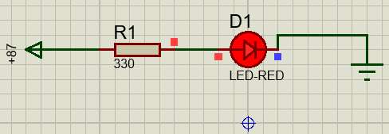

* 1. **Turn on 2 LEDs connected in parallel using 12 VDC.**

The circuit works properly, since the voltage in parallel remains constant.

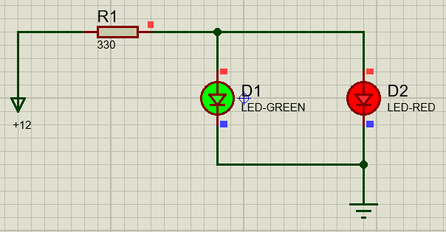

* 1. **Turn on as many LEDs as you can connected in series using 12VDC**

I could only connect one LED in series, because the moment I connect a second LED, the circuit opens and it is unable to power both.

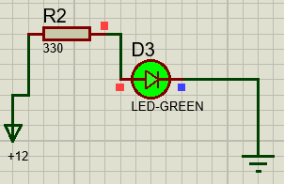

* 1. **Turn on a LED using a common NPN bipolar transistor using a 12 VDC power supply for the LED and a 5 VDC as a trigger pulse; when the pulse is at the high level, the LED turns on and when the pulse is at low level, the LED is turned off.**

The circuit works properly, but instead of a power supply, used a switch and it works the same way.

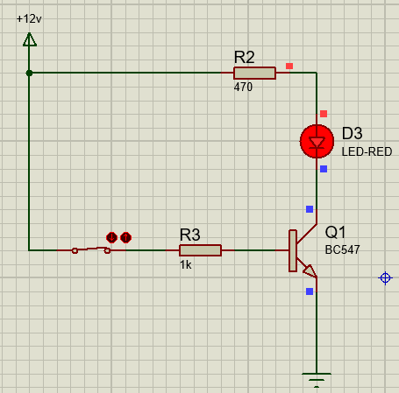

**Send your answers using private message tomorrow before 8pm.**